**Practical : 07**

**Aim**: Demo of Principal component analysis.

Theory : Principal Component Analysis is basically a statistical procedure to convert a set of observations of possibly correlated variables into a set of values of linearly uncorrelated variables. Each of the principal components is chosen in such a way so that it would describe most of them still available variance and all these principal components are orthogonal to each other. In all principal components first principal component has a maximum variance.

Uses of PCA:

• It is used to find inter-relation between variables in the data.

• It is used to interpret and visualize data.

• The number of variables is decreasing it makes further analysis simpler.

• It’s often used to visualize genetic distance and relatedness between populations.

Code:

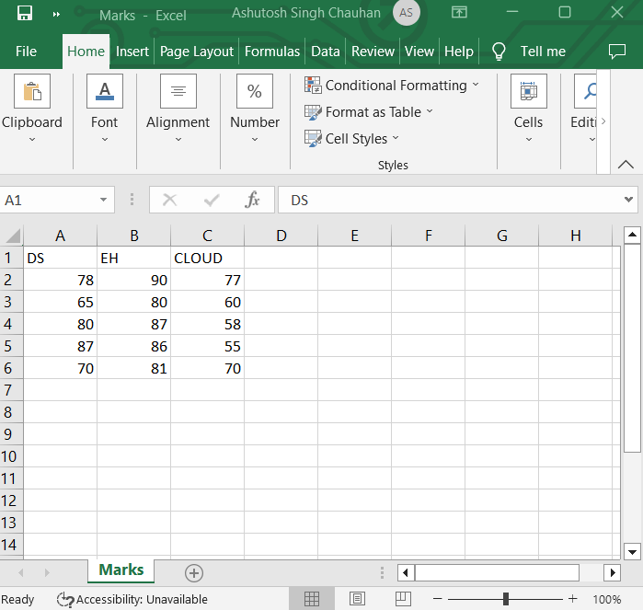

> install.packages(“FactoMineR”)

> install.packages(“factoextra”)

> library(“FactoMineR”)

> library(“factoextra”)

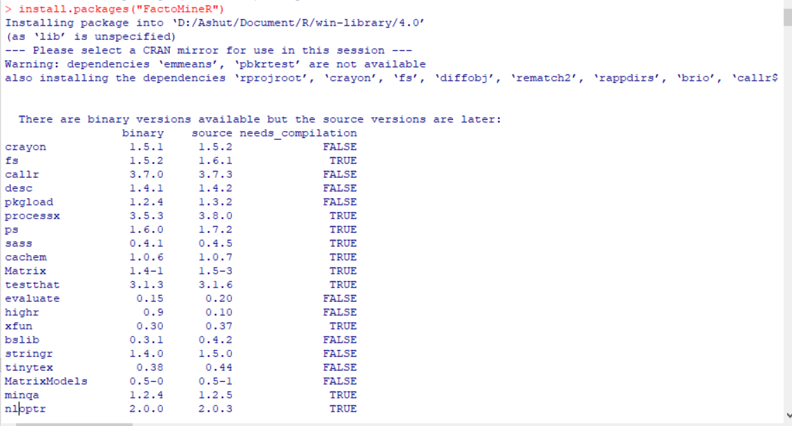 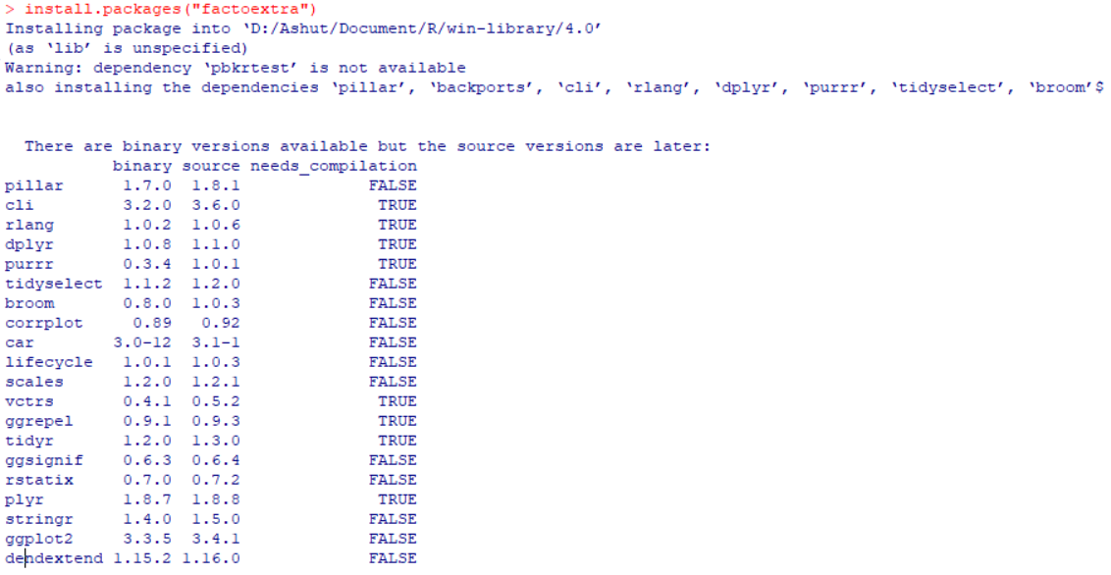 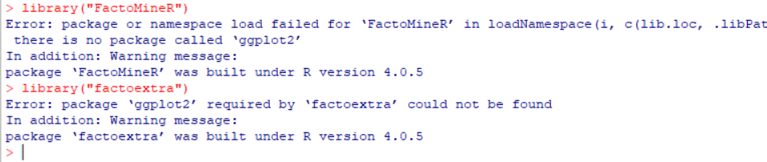

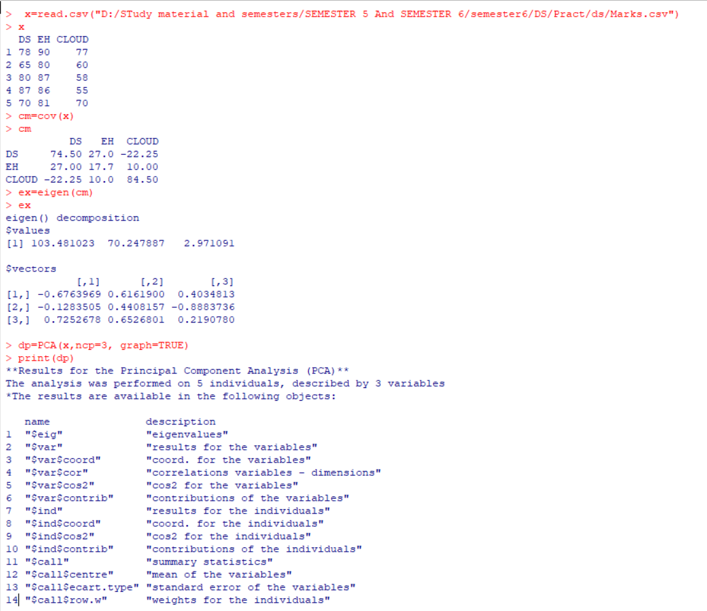 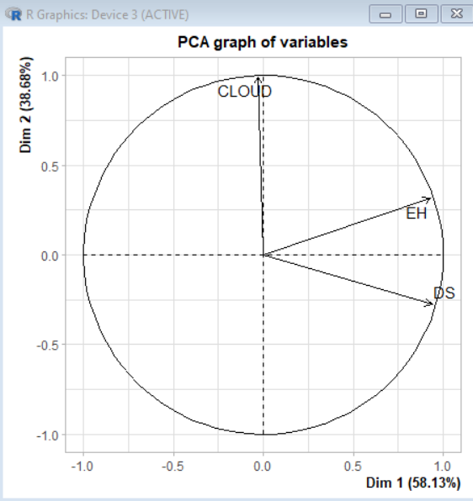

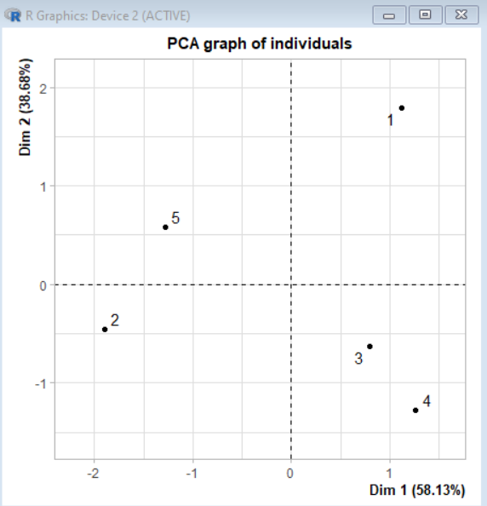

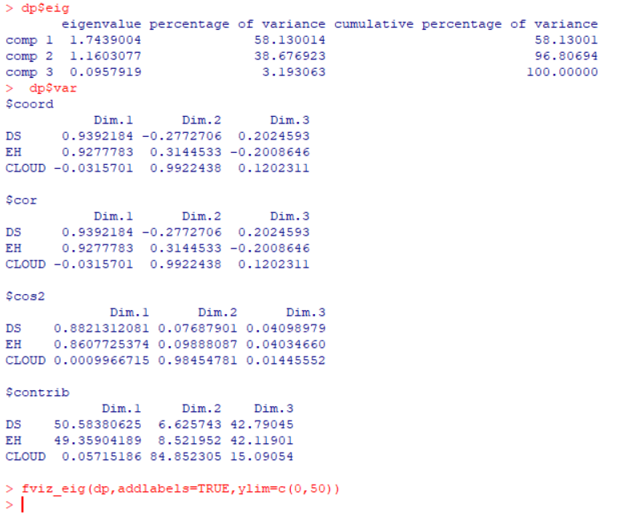

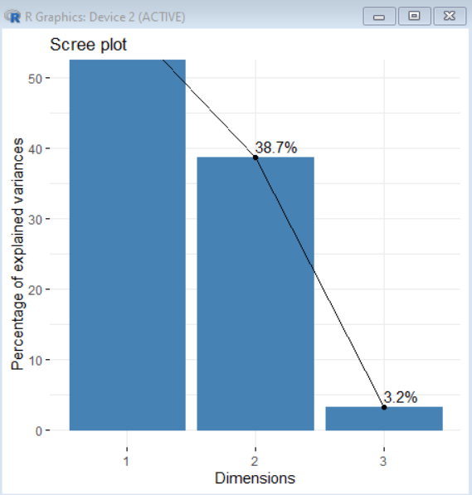

Implementing PCA on IRIS dataset

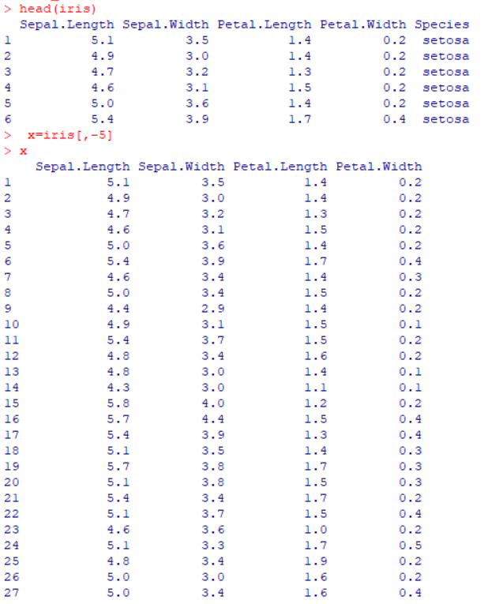

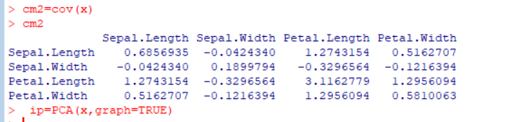

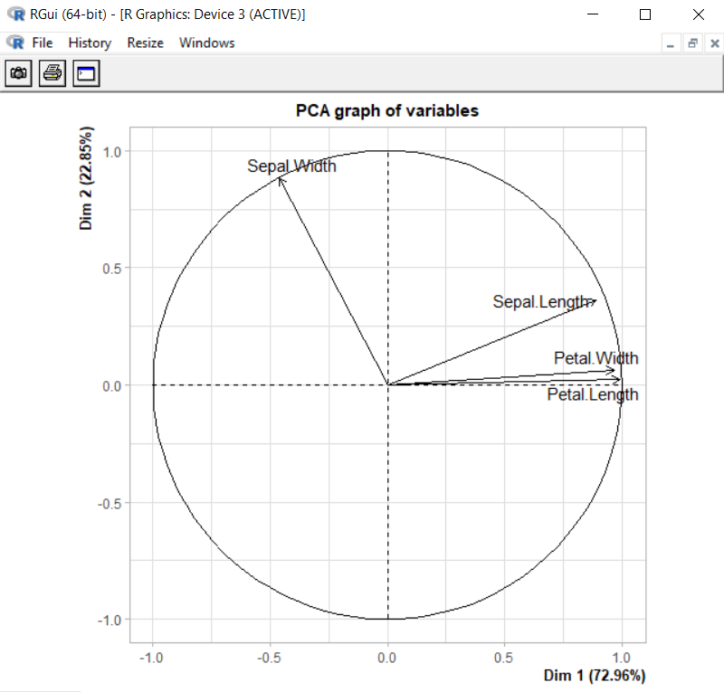

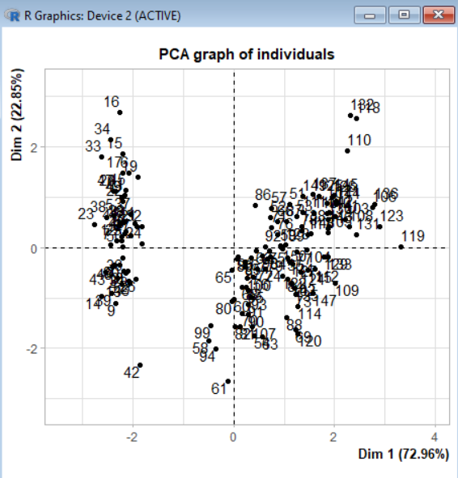 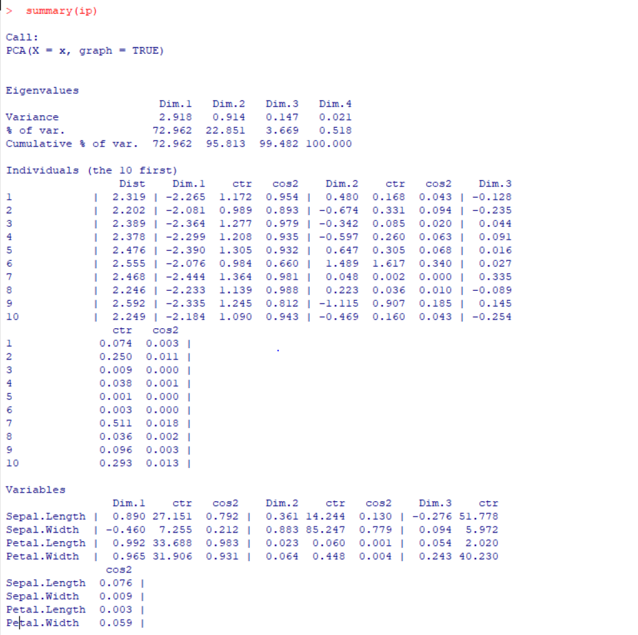

**Conclusion :** Principal component analysis (PCA) is a popular technique for analyzing large datasets containing a high number of dimensions/features per observation, increasing the interpretability of data while preserving the maximum amount of information, and enabling the visualization of multidimensional data.